ADVENTURE WORKS · TECHNICAL SUPPORT

Diagnosing Creaks, Clicks, and Knocks
Frame & Noise Document TS-007 Rev. A
Applies to | All Adventure Works models
Difficulty | Intermediate
Time required | 30 – 60 minutes
Tools needed | Hex & Torx keys, Torque wrench, Bike-specific grease & anti-seize, Clean rags

Symptoms
- A creak that appears with each pedal stroke.
- A click felt through the bars, saddle, or pedals.
- Noise that changes when you stand vs. sit, or in/out of the saddle.
- A knock over bumps that you can't localize.
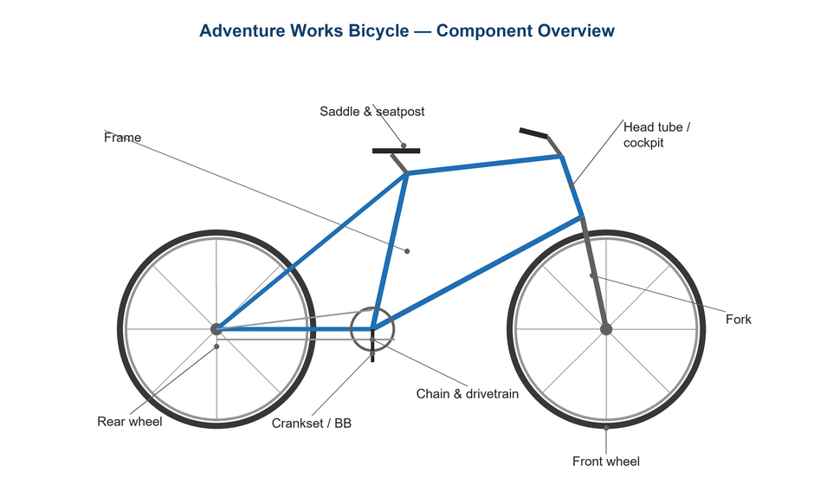
Figure 1. Work methodically through each interface to isolate the noise.

Likely Causes
- Dry or under-torqued interface (pedals, crank, seatpost, stem, bottle cage).
- A loose bottom bracket or headset.
- Chainring or cassette bolts that have loosened.
- Dry seatpost or saddle rail clamp.
- Surprising culprits: water bottle cage, wheel skewer, or even shoe cleats.
Safety first
- Re-torque every fastener to spec — over-tightening can crack carbon or strip alloy threads.
- Use the correct grease or carbon assembly paste for each interface.
- Recheck critical bolts (stem, seatpost, pedals) before riding.

Customer Fix — Step by Step
Suitable for home repair with basic tools. Work through the steps in order.
- Try to reproduce the noise: note exactly when it happens (pedaling, bumps, braking, standing).
- Eliminate the obvious: remove the water bottle and cage and ride — many 'frame creaks' are a loose cage.
- Check pedal tightness; remove, grease the threads, and reinstall to spec (remember the left pedal is reverse-threaded).
- Confirm the seatpost is greased (or has carbon paste) and the clamp is at spec; a dry post is a classic creak source.
- Tighten the stem and chainring bolts to spec, one at a time.
- If the noise persists with pedaling under load, suspect the bottom bracket or crank (technician step).

Technician Reference
Additional checks and adjustments for service technicians and advanced users.
- Isolate by section: pedal off the bike to test the BB/crank; coast to test the wheels/drivetrain.
- Remove, clean, grease, and re-torque the crank and bottom bracket; replace a notchy or play-laden BB.
- Service the headset bearings and set preload so there is no play but the bars rotate freely.
- Check chainring bolts, cassette lockring, and pedal spindles for play.
- Inspect frame interfaces (cable guides, derailleur hanger, seatpost collar) and apply appropriate paste/grease.
- Confirm wheel skewers/thru-axles and dropout faces are clean and torqued.

Torque & Specifications
Fastener | Torque
Pedals | 35 N·m
Seatpost clamp | 5 – 7 N·m
Stem (bar & steerer) | 5 – 6 N·m
Chainring bolts | 8 – 10 N·m
Bottle cage bolts | 3 – 4 N·m
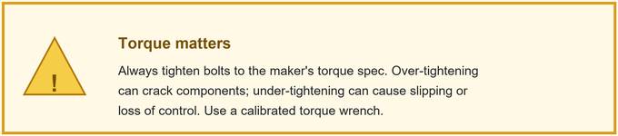
Figure 2. Correct torque eliminates most creaks and protects components.
Pro tips
- Change one thing at a time and test, or you'll never know which fix worked.
- Most creaks are an unlubricated, correctly-or-incorrectly torqued interface — not a broken part.

When to Visit a Service Center
- The noise persists after servicing pedals, seatpost, BB, and headset.
- You suspect a cracked frame or a failing bearing.
- A press-fit bottom bracket needs special tools to remove.
- Carbon components are involved and you're unsure of safe torque.
This guide is provided for reference. Torque values are typical starting points — always follow the specific component manufacturer's instructions. © Adventure Works.

